Shah Shashwat Nimesh, Sheet 1 of 8
Shah Kruti Bhavesh, Total number of Sheets - 8
Gupta Manasvi Ganesh,
Jobanputra Khushi Dharmendra ,
Karani Ruhina,
Application Number:
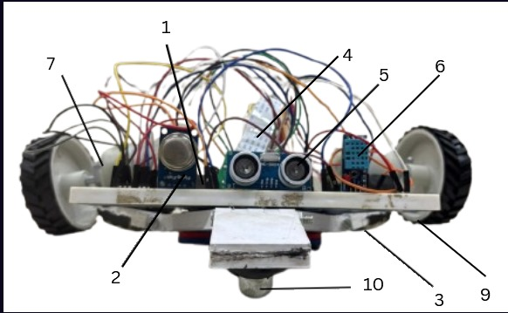
Figure 1

Shah Shashwat Nimesh
Applicant

Shah Shashwat Nimesh, Sheet 2 of 8
Shah Kruti Bhavesh, Total number of Sheets - 8
Gupta Manasvi Ganesh,
Jobanputra Khushi Dharmendra ,
Karani Ruhina,
Application Number:

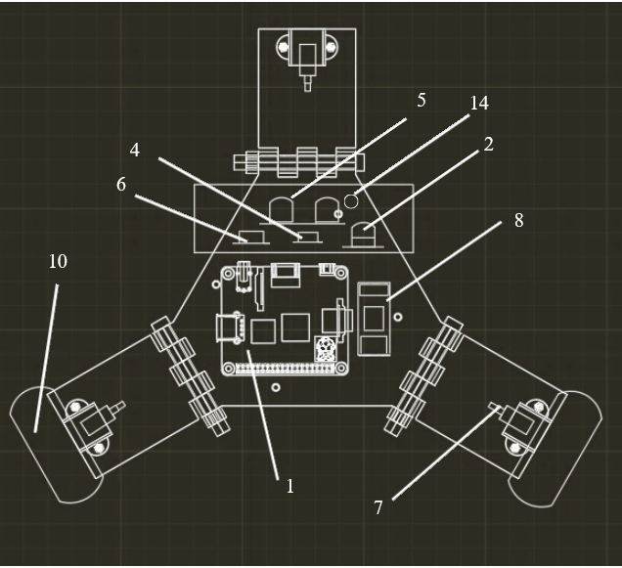
Figure 2.

Shah Shashwat Nimesh
Applicant

Shah Shashwat Nimesh, Sheet 3 of 8
Shah Kruti Bhavesh, Total number of Sheets - 8
Gupta Manasvi Ganesh,
Jobanputra Khushi Dharmendra ,
Karani Ruhina,
Application Number:
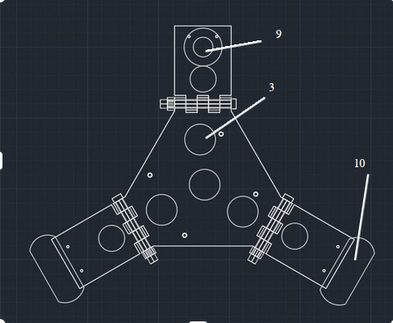Figure 3

Shah Shashwat Nimesh
Applicant

Shah Shashwat Nimesh, Sheet 4 of 8
Shah Kruti Bhavesh, Total number of Sheets - 8
Gupta Manasvi Ganesh,
Jobanputra Khushi Dharmendra ,
Karani Ruhina,
Application Number
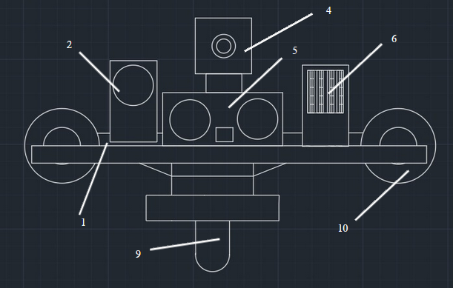Figure 4

Shah Shashwat Nimesh
Applicant

Shah Shashwat Nimesh, Sheet 5 of 8
Shah Kruti Bhavesh, Total number of Sheets - 8
Gupta Manasvi Ganesh,
Jobanputra Khushi Dharmendra ,
Karani Ruhina,
Application Number

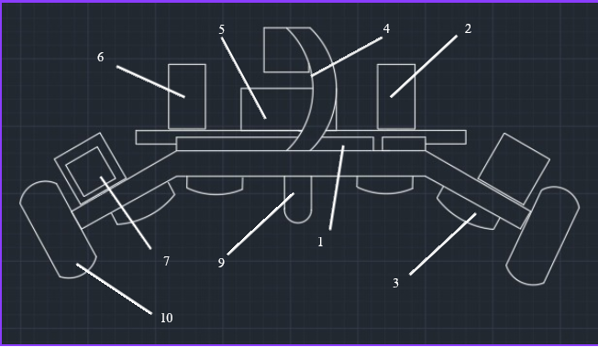Figure 5

Shah Shashwat Nimesh
Applicant

Shah Shashwat Nimesh, Sheet 6 of 8
Shah Kruti Bhavesh, Total number of Sheets - 8
Gupta Manasvi Ganesh,
Jobanputra Khushi Dharmendra ,
Karani Ruhina,
Application Number

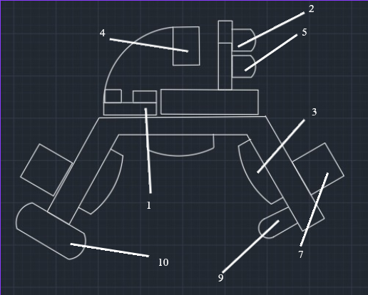
Figure 6
Shah Shashwat Nimesh
Applicant

Shah Shashwat Nimesh, Sheet 7 of 8
Shah Kruti Bhavesh, Total number of Sheets - 8
Gupta Manasvi Ganesh,
Jobanputra Khushi Dharmendra ,
Karani Ruhina,
Application Number

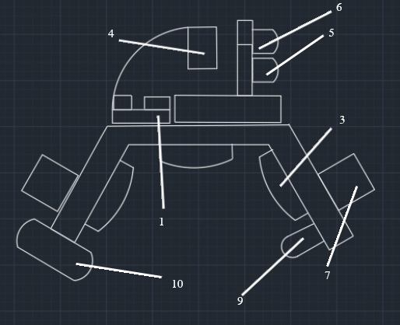
Figure 7

Shah Shashwat Nimesh
Applicant

Shah Shashwat Nimesh, Sheet 8 of 8
Shah Kruti Bhavesh, Total number of Sheets - 8
Gupta Manasvi Ganesh,
Jobanputra Khushi Dharmendra ,
Karani Ruhina,
Application Number

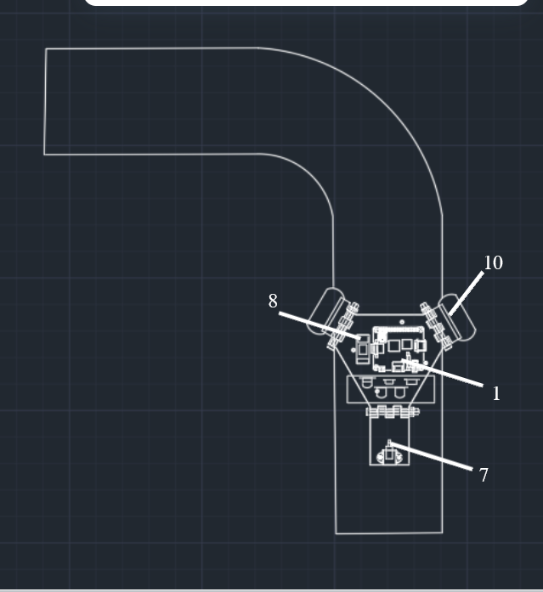
Figure 8

Shah Shashwat Nimesh
Applicant

